**Booked BV**

**URS**

**Name:** Steven Chen

**Class:** S2-CB02

**Date:** 14-05-2023

**Version:** 1.3

**Contents**

**1.** **Agreement with client** 3

**2.** **Functional requirements** 4

**Desktop application:** 4

**Web application:** 4

**3.** **Use cases** 6

**4.** **GUI** 11

# **Agreement with client**

During the meetings with the client (John Smith), we discussed about the necessity that the company wants and ask question to the client on how he want the product to look like.   
In the meetings the client told us that the main priority is to get a website where client can book a flight or hotel and a desktop application to manage them.

Therefore we have decided upon for the entire semester to work on these 2 application as the main priority. Additional feature to improve the application could be added if there is enough time, but the main feature will be the priority. The main features of these application will be further explained in this document and the uses of them.

# **Functional requirements**

For these applications there are 2 actors which consist of the clients which here is referred to as the “User” and the administration where they add content to the website which is referred to in these functional requirements and Use Cases as the “Admin”.

## **Desktop application:**

**ID: FR-09**

Name: Admin can view all bookings/users

**ID: FR-10**

Name: Admin can add new flights/hotels to the website

**ID: FR-11**

Name: Admin can delete flights/hotels from the website

**ID: FR-13**

Name: Admin can change/update the information of flight/hotels

**ID: FR-14**

Name: Search/filter user, flight, booking

**ID: FR-18**

Name: Check if the hotels/ flight exist or not

## **Web application:**

**ID: FR-01**

Name: User can log in

**ID: FR-02**

Name: User can make an account

**ID: FR-03**

Name: User can search/filter for hotels or flights

**ID: FR-04**

Name: User can book a hotel/flights

**ID: FR-05**

Name: User can add a review on a hotel

**ID: FR-06**

Name: User can cancel their booking

**ID: FR-07**

Name: User can view all the bookings made

**ID: FR-08**

Name: User can change their personal information

**ID: FR-12**

Name: The website calculates the price based on the room of the hotel

**ID: FR-15**

Name: The website calculates the price based on the seats and baggage on the flight.

**ID: FR-16**

Name: Check if the hotel/flight is available or not.

**ID: FR-17**

Name: Check if the user account exists or not.

# **Use cases**

**Web application:**

**ID: UC-01 (FR-01)**

Use Case: User can log in

Actor: User

Main Success Scenario:

1. User click on the log in button
2. User fills in the email and password
3. User goes back to home page and is logged in

Extensions:

3a. Wrong credentials

1. User gets informed that the credential is wrong
2. Return MSS 2

**ID: UC-02 (FR-02)**

Use Case: User make account

Actor: User

Main Success Scenario:

1. User goes click “Create an account” link in login page
2. User goes to the register page
3. User fills in personal information
4. User goes back to home page, the account is created and user is logged in

Extensions:

3a. Any required details of the user is missing

1. Displays a message about user detail is missing
2. Return MSS 3

**ID: UC-03 (FR-03)**

Use Case: User can search/filter for hotels or flights

Actor: User

Main Success Scenario:

1. User search for a flight/hotels picks a leave date and return data
2. Click on search button
3. Content will be shown

Extensions:

3a. Any required details of the user are missing

1. Displays a message about user missing
2. Return MSS 1

**ID: UC-04 (FR-03, FR-04)**

Use Case: User can books hotels/flights

Actor: User

Main Success Scenario:

*Precondition: User must be logged in and User could cancel with a button any time.

1. User search for a flight/hotels picks a leave date and return data
2. Click on search button
3. Content will be shown
4. User select a content
5. User click book button
6. Goes to a payment page and user fills credentials
7. Flight/Hotel is booked to the user

Extensions:

7a. Any required details of the user are missing

1. Displays a message about user detail is missing
2. Return MSS 6

**ID: UC-05 (FR-05)**

Use Case: User can add reviews on hotels

Actor: User

Main Success Scenario:

*Precondition: User must be logged in.

1. User select a content
2. User goes to the detailed page of the hotel
3. User can write a review and give rating on the page
4. Click the add review button
5. Review is added

Extensions:

5a. Any required field is missing

1. Displays a message about field is missing
2. Return MSS 2

**ID: UC-06 (FR-06, FR-07)**

Use Case: User can cancel booking

Actor: User

Main Success Scenario:

*Precondition: User must be logged in and User could cancel with a button any time.

1. User goes to their personal page
2. Click a tab to view all booking made
3. User select one of the booking
4. User click cancel booking button

**ID: UC-07 (FR-08)**

Use Case: User changes personal information

Actor: User

Main Success Scenario:

*Precondition: User must be logged in and User could cancel with a button any time.

1. User goes to their personal page
2. Click personal information tab
3. User click change personal information
4. User writes changes
5. Personal information has been changed

Extensions:

5a. Any field is missing

1. Displays a message about field is missing
2. Return MSS 4

**Desktop application:**

**ID: UC-08 (FR-09)**

Use Case: Displaying every user/bookings

Actor: Admin

Main Success Scenario:

1. Admin clicks on "Bookings"
2. Admin sees a list of all the bookings

Extensions:

1a. Admin clicks on Users

1. Admin sees a list of all Users

**ID: UC-09** **(FR-010)**

Use Case: Add hotels/flight to the website

Actor: Admin

Main Success Scenario:

1. Admin clicks the "Add hotels/flights
2. Admin fills in the details of the hotel/flight that is going to be added to system.
3. Hotel/flight has been added to the website

Extensions:

3a. Any required details of the user are missing

1. Displays a message about field is missing
2. Return MSS 2

**ID: UC-10 (FR-011)**

Use Case: Remove flight/hotels from website

Actor: Admin

Main Success Scenario:

1. Select a hotel/flight from the list
2. Admin clicks the Remove button
3. System shows a warning message about confirming the removal of the booking
   1. Trigger: Confirm removal is triggered
4. Selected booking is removed

Extensions:

3a. No content is selected

1. System displays a message about no booking is selected
2. End of use case

4a. Selected 'Cancel' on warning message about confirming the removal

1. System displays that removal has been cancelled
2. Return MSS 2

# **GUI**

**Wireframes:**

Home page

Hotel page

Detailed hotel page

Flight page

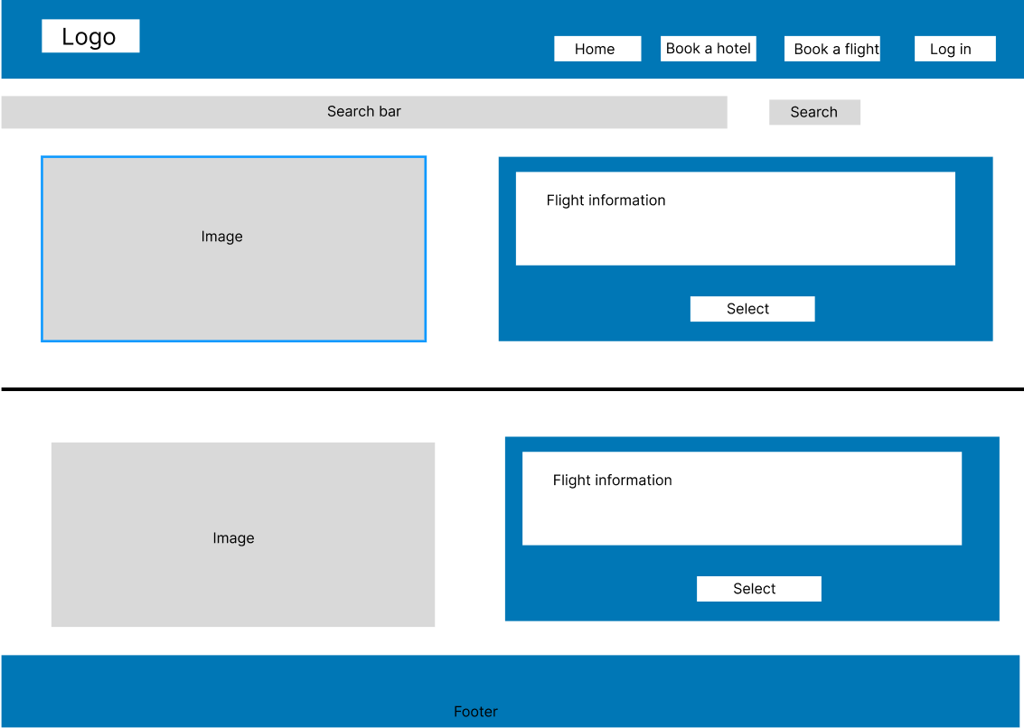

Detailed flight page

Log in page

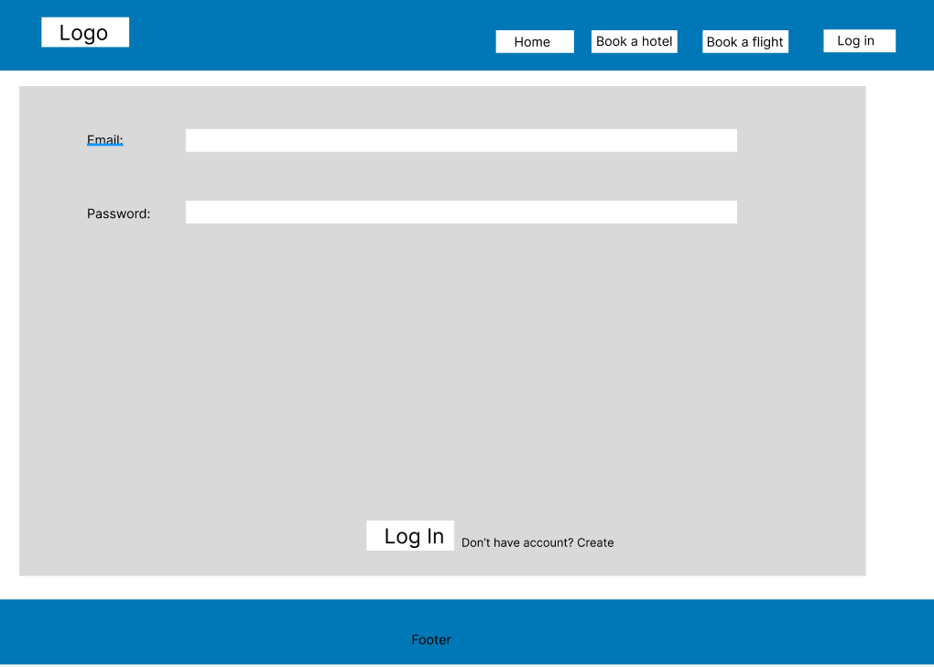

Sign up page

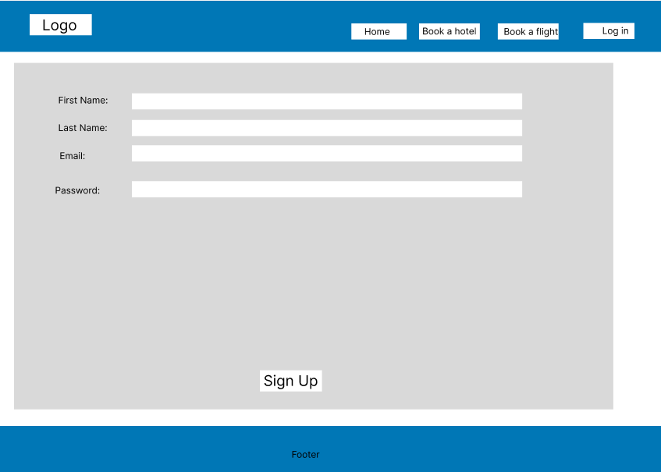

**Desktop application:**

**Main form:**

**Hotel section:**

**Add hotel:**

**Update hotel**

**Flight section:**

**Add flight:**

**Update flight:**

**Web application:**